Driving Directions to Cedar Crest College
From around the Lehigh Valley, take Route 22 to the Cedar Crest Blvd. Exit. Turn left onto Cedar Crest Blvd. and travel through four traffic lights. Turn left onto the campus.
From the Pennsylvania Turnpike, take the Northeast Extension (I-476 formerly PA Route 9) to Exit 56 (Formerly Exit 33 Lehigh Valley). Follow Route 22 East to Cedar Crest Blvd. Turn left onto Cedar Crest Blvd. and travel through 4 traffic lights. Turn left onto the campus.
From Route 309 and Interstate 78 (309 and 78 merge together) follow 309/78 to Cedar Crest Blvd. Exit 55. If traveling 309 S/78 E turn left on Cedar Crest Blvd. and travel through 5 traffic lights. Turn right onto campus. If traveling 309 N/ 78 W turn right onto Cedar Crest Blvd. and travel through 4 traffic lights. Turn right onto campus. 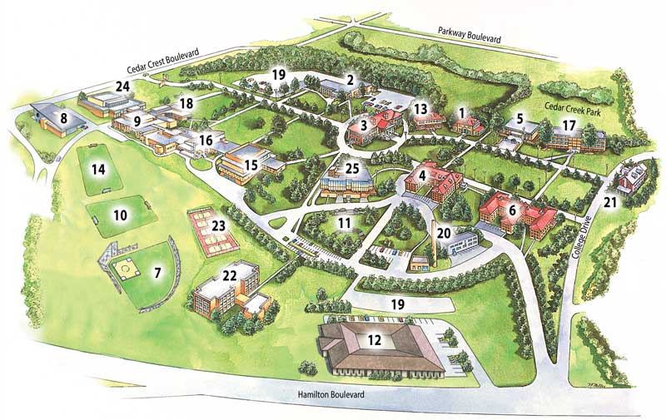
When entering campus from Cedar Crest Blvd, make your first R to drive past the Rodale Aquatic Center building #24. Turn L to drive past building #9 The Dorothy Pool Rider Science Center and follow this road to the parking lot in front of Steinbright Hall.
Parking is plentiful in the lot between #22 Steinbright Hall and #25 Tompkins College Center. There is a walking path that connects the two buildings.
Building #25 is Tompkins College Center. The Tap Ties Registration Desk and Samuels Theatre are located here. Most tap classes and the Performance Showcase take place at this location. Please report here FIRST to receive Welcome Packet with t-shirt and tickets if ordered. Performance Showcase Tickets will be on sale at this location throughout the day.
Building #22 is Steinbright Hall Dance Studio. ONLY Advanced and INT/ADV classes take place here.

