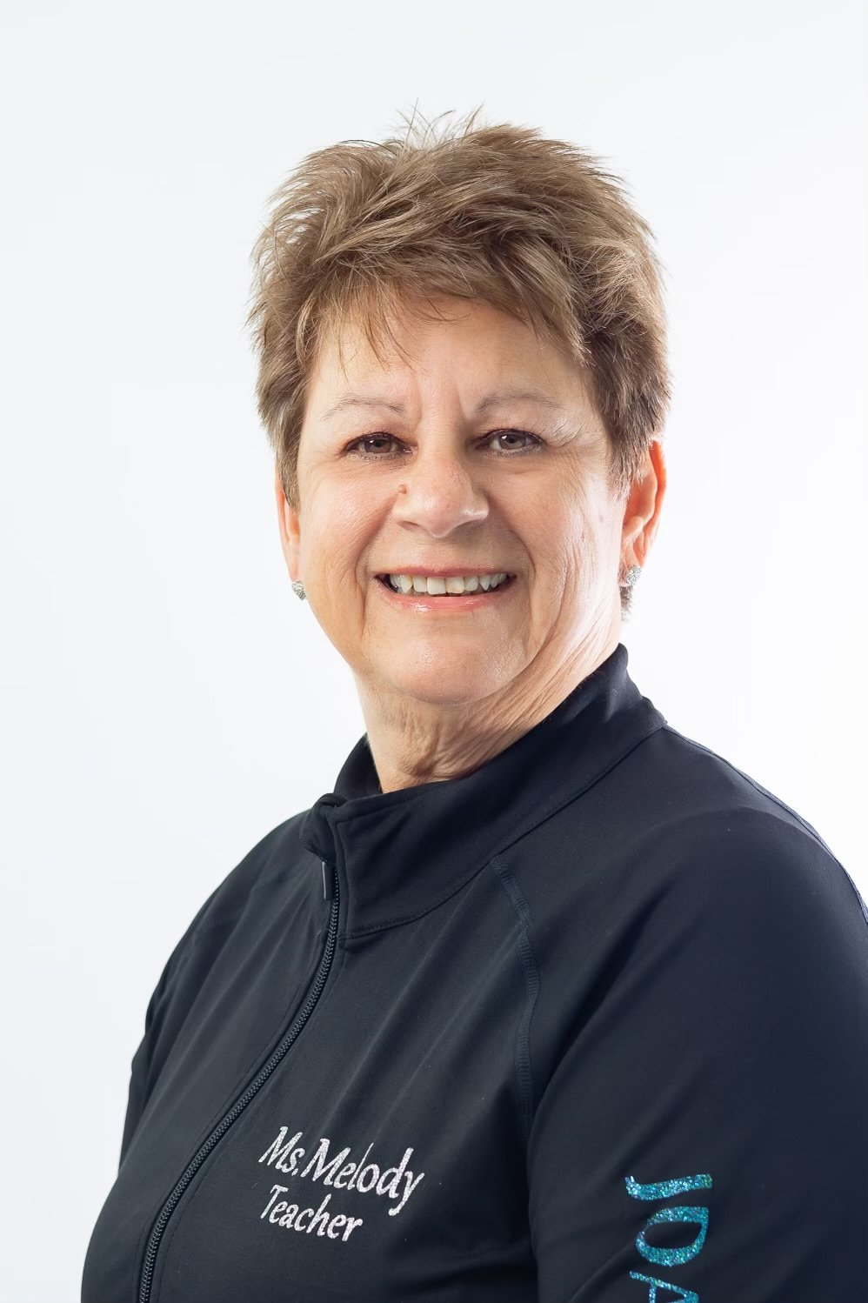
Melody Kline, originally from Staten Island, New York and now residing in South Florida, is an accomplished tap dancer who started dancing at age three. Beginning at Chickie’s Dance Studio, her mother’s school, Melody found the love of dance that stayed with her studying Ballet, Tap, Jazz, and Acro. She continued her training through high school while attending the famous High School of Performing Arts in NYC. When she relocated to PA., in 1976 she started her own dance school, Melody’s Dance Studio, in the beautiful Pocono Mountains of Pennsylvania which she ran for 37 years. While directing the studio, teaching and raising a family, Melody continued her dance studies in NYC at both Steps and Broadway Dance Center studying with some of the best in the dance world, including Paul Draper, Bob Audy, Frank Hatchett, Charles Kelly, Shiela Barker, Don Farnsworth, and Germaine Salsberg. In Pennsylvania she studied with Nicole Hockenberry and Shelley Oliver, and became a member of the company T.A.P. -Teach All People, where she performed for many tap venues and festivals, the Third Coast Rhythm Project in San Antonio, TX. as well as the first of many T.A.P. concerts, where she shared the stage with master tap dancers, LaVaughn Robinson, and Dr. James “ Buster” Brown. She was also a founding member of Tap Ties, performing choreography from Nicole Hoceknberry and Shelley Oliver and Germaine Salsberg to name a few. For the last six years, Melody has held adult tap classes of her own and has subbed at various studios in all forms of dance in the South Florida area.

